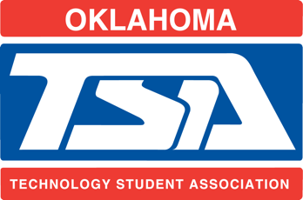 | Oklahoma TSA Alumni Scholarship

Recipient Application

Applicant Information
Full Name: |  |  |  | Date:
 | Last | First | M.I.

Address:
 | Street Address | Apartment/Unit #

 | City | State | ZIP Code

Phone: |  | Email

Year of Graduation: |  | Current Chapter.: |  | Years in TSA:

Current Oklahoma TSA Member? | YES | NO

Plan to attend State Conference? | YES | NO

Education
What are your Post-Secondary Plans?

Do you plan to pursue a job in a STEM related field? | YES | NO

Disclaimer and Signature
I certify that my answers are true and complete to the best of my knowledge and that I meet the eligibility requirements for the Oklahoma TSA Alumni Association Scholarship.
Signature: |  | Date:

The following questions should be answered and typed on a separate piece of paper and emailed in with your application.

- List all TSA Awards and Accomplishments you have received in your years in TSA
- List all Offices held within TSA local, regional, state, and national level.
- Describe how you hope to become an active member of the TSA Alumni Association and in what ways you plan on contributing or areas you would like to improve. (500 words or less)
- Briefly describe your long and short term goals. (500 words or less)

Additional application requirements

Please email in the following with your application:

- 1 letter of recommendation from your TSA Chapter Advisor
- High School Transcript

All application material must be emailed to oktsaalumni@gmail.com by March 15th, 2019.

The applications will be reviewed and the Semi-Finalists will be notified via email by April 1st, 2019
The Semi-Finalists will then be interviewed onsite at the State Conference 2019.
The Semi-Finalists will be introduced at the Alumni Association Senior Banquet on April 11th, 2019.
The Scholarship recipient will be announced at the closing session of the State Conference on April 12th, 2019.

